|  |  |
| --- | --- |
| Canon EOS 5D Mark IV Camera  Canon EOS 5D Mark IV 1 Canon EOS 5D Mark IV Canon EOS 5D Mark IV 3 Canon EOS 5D Mark IV 2 | **Featured information:**  Sensor: Full-Frame  ISO range: 100 - 32000 (expandable 50 - 102400)  Resolution: 30.4MP  Wireless connection: WiFi  **Price:** 2000$  **Specifications:**  **Sensor Format:**  Full-Frame (1x Crop Factor)  **Resolution:**  31.7 Megapixels  **Size photo:**  6720 x 4480  **Image Proportions:**  1:1, 3:2, 4:3, 16:9  **Sensor Type:**  CMOS  **Image Format:**  JPEG, Raw  **Anti-Vibration:**  No  **Lens Mount:**  Canon EF |

**Overview:**

The Canon EOS 5D Mark IV has a large 3.2-inch LCD touch screen with 1.62 million pixels and an anti-reflective layer that helps display truly excellent outdoor images.

The dedicated AF mode selector button gives users quick access to focus options, making this job really smooth and easy.

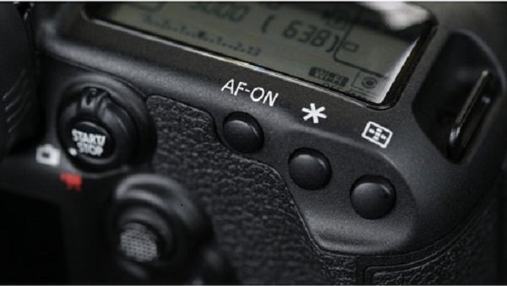

The camera has dual memory card slots to help increase storage capacity for users.

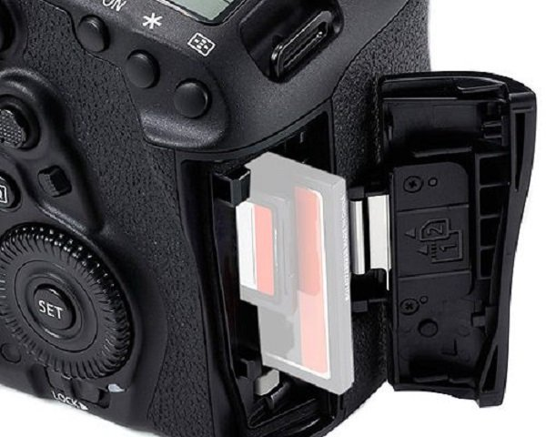

The smart viewfinder is designed so that the user sees the AF points highlighted in red. In addition, the viewfinder can also display a series of parameters such as grid, white balance, metering mode, AF information and other settings - an extremely smart and extremely modern design on the camera. This picture.

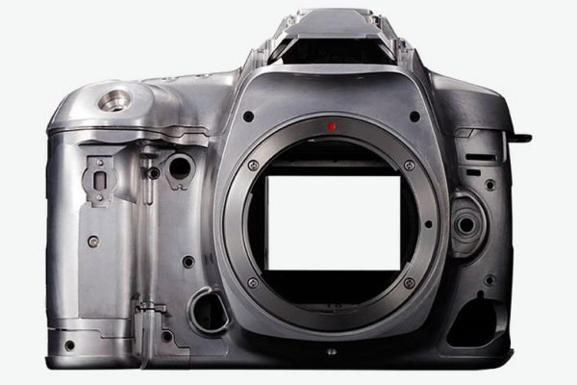

The body of the device is made of Magnesium alloy - an extremely high-quality alloy that provides a truly "worth-the-money" grip and usage experience as well as allowing the device to operate well in many other harsh environmental conditions. together.

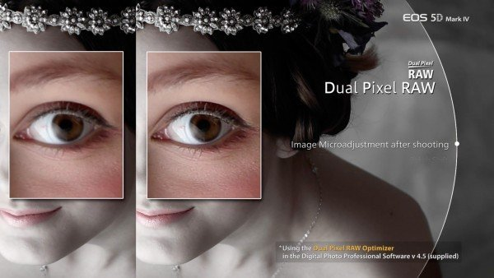

This is a new technology that Canon developed and was first deployed on this Canon EOS 5D Mark IV model. This technology helps users adjust sharpness at a small amplitude, adjust Bokeh more beautifully and help reduce shadow effects in a smoother way.